## View In Browser

1. Install the following extension:

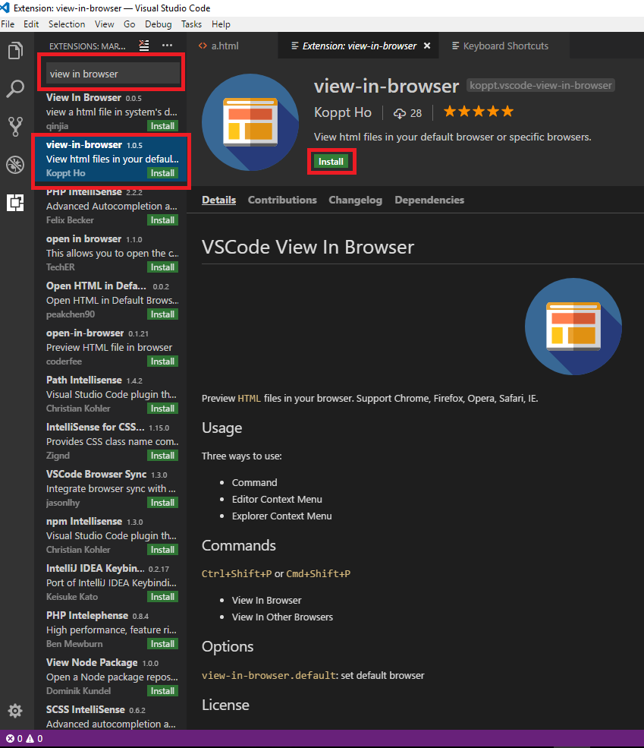

(Find more details about this extension in this link: <https://marketplace.visualstudio.com/items?itemName=koppt.vscode-view-in-browser> )

1. Create a simple html file:

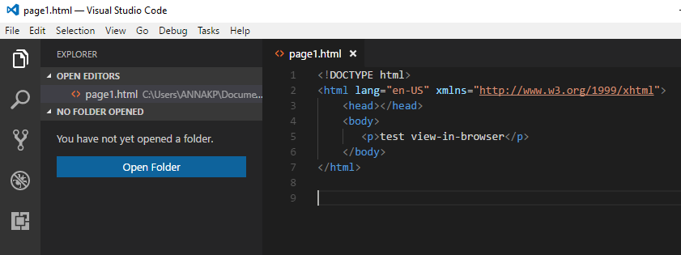

1. Press Ctrl+Shift+P and select View In Browser

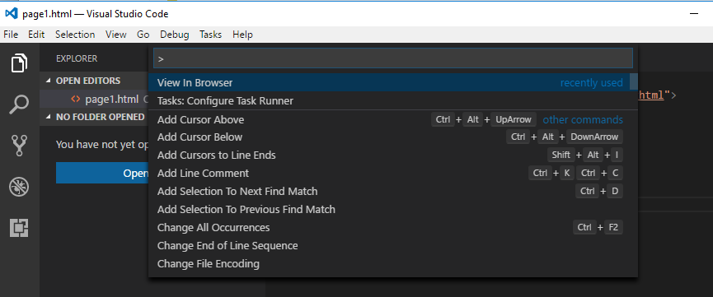

1. See the following result in your browser:

